ATLAS: A Living Encyclopedia for the AI Era
Development guide v0.1 · working name ATLAS (rename freely) · 18 October 2026. Sections 1–14 are the guide; sections 15–21 hold the C4 diagrams (levels 1–3), the class diagram and the BPMN-style activity diagrams; section 22 adds missing pieces.

1. Vision, scope and design principles
Definition. ATLAS is a versioned, community-governed map of what a discipline knows, where its knowledge is concentrated, where it is missing, and how findings differ between the world aggregate and specific societies, cultures and eras. AI agents propose; communities and verification gates dispose.
Three layers share one data spine:
- Knowledge layer (agents): acquire → process → classify → extract claims → synthesize → write entries.
- Experience layer (readers): zoomable map, entries at several depths, a social discovery feed, a learning mode.
- Governance layer (community): fork, propose, review, vote, merge, with AI recommendations.
Design principles (they drive every later choice):
- Provenance first. Every sentence in a public entry resolves to claim IDs, and every claim to a source span. If it cannot be traced, it is not published as fact.
- Gaps are first-class objects. A gap has an ID, a coverage-confidence estimate and a history, like any entry.
- Plurality over averaging. Show distributions of findings and competing interpretations, not one blended paragraph. Consensus is computed, labelled, and contestable.
- Agents propose, process disposes. AI output enters as a proposal with a visible status label; nothing AI-drafted skips verification.
- Deterministic where possible, agentic where necessary. Fixed workflows for parsing, dedup and statistics; agents only where judgment is needed (alignment, synthesis, critique).
- Documents are untrusted input. PDFs can carry prompt injection, so extraction agents never hold tools with side effects.
- Model-collapse guard. AI-written entries are tagged and excluded from the evidence corpus; only primary sources feed the claim graph.
- Situated by default. Every claim carries its context (where, who, when, language), because the world-vs-society comparison depends on it.

2. What to inherit from the history of reference works
Selection rule: adopt an innovation if it scores high for readers or for agents, costs little to implement, and harms neither.
Innovation | Origin | Helps readers | Helps agents | ATLAS feature
Outline of knowledge + tiered depth | Britannica (Propædia, Macropædia, Micropædia) | Orientation; choose depth | Fixed schema per entry type | The map + five reading depths
Multimedia and interactive timelines | Encarta | Concrete, engaging | Structured assets to generate | Zoomable donut, timeline, streamgraph
Open editing, revision history, talk pages | Wikipedia | Trust through transparency | Audit trail, feedback signal | Branches, proposals, discussion threads
Structured claims with references | Wikidata | Machine-readable facts | Verifiable generation targets | Claim graph with source spans
State-of-field reviews with future directions | Handbooks, Annual Review series | Authoritative synthesis | Synthesis templates | What is known / unknown briefs
Evidence tables and risk-of-bias appraisal | Cochrane/Campbell-style reviews | Calibrated confidence | Grading rubric | Evidence cards, graded claims
Faceted classification and cross-references | Library of Congress Classification, thesauri | Findability | Stable routing keys | LCC-style tree + see-also links
Dated, citable versions | Stanford Encyclopedia of Philosophy | Citability | Stable IDs | Snapshot releases with DOIs
Embedded live charts | Our World in Data | Data literacy | Chart-as-code | Chart specs inside entries

3. Pedagogical design (evidence-based)
- Cognitive load and multimedia principles (Sweller; Mayer): signaling, segmenting and coherence → short entries, progressive disclosure, labels placed next to the thing they label, no decorative animation.
- Expertise reversal (Kalyuga): guidance helps novices and hampers experts → explicit reading levels (Map, Brief, Article, Evidence, Method, Source), with a default chosen from the reader’s stated background.
- Retrieval practice and spacing (Roediger & Karpicke; Cepeda et al.): auto-generated questions from verified claims, resurfaced on a spaced schedule in the feed. Questions are checked against the claim graph before release.
- Cognitive flexibility theory (Spiro): ill-structured domains need multiple perspectives and case-based criss-crossing → side-by-side interpretations and “same case, different frames” views.
- Concept maps (Novak) and threshold concepts (Meyer & Land): the donut is a concept map; threshold concepts are flagged inside entries.
- Worked examples: one published study walked through the method DAG, step by step.
- Lateral reading and source evaluation: a one-click “see the sources” affordance on every claim.
- Equity: Spanish-first, plain-language level, low-bandwidth mode, offline packs, and visible regional literature.
Measure learning (pre/post comprehension and delayed retention), not time on site.

4. System overview and the knowledge model
Core idea: one claim graph, one taxonomy, one method-DAG store; entries are generated views over them.
Main entities: Work → Document → Section → Span; Claim and its Context; EvidenceLink; TaxonomyNode; Concept and ConceptCluster; Frame (an interpretive position); MethodDAG and MethodStep; Gap; Entry (typed); Branch, Proposal, Review, Vote; AgentRun; Person (author profile). Section 18 shows the class diagram.
Claim schema: subject, relation, outcome, direction and magnitude when reported, population, study site, era of data collection (not publication), source language, method type, claim type (finding, interpretation, limitation, recommendation, theory statement), evidence grade, source span, extractor version, confidence.
Three geographies, kept apart: study site, author affiliation, publication language. The world-vs-society comparison uses study site; the equity audit uses the other two.
Taxonomy. Internally a DAG, because handbooks file a topic under several parents. Publicly a tree with one primary placement per node plus see-also cross-links, in LCC-style notation (for example class H, subclass HM for sociology). Check licensing for any LCC schedules you copy; the Library of Congress linked-data service is a good seed.

5. Pipeline, stage by stage
Stage 0 — Taxonomy bootstrap (initial agent). Inputs: tables of contents and indexes of handbooks and reference works, LCC/LCSH, OpenAlex topics. Extract hierarchies → align nodes across sources (embedding similarity, LLM adjudication, human review of low-confidence merges) → build the DAG recording which source asserts which edge → project to a tree → assign notation. Disagreement between handbooks is kept as data. Sibling order for the donut comes from seriation (optimal leaf ordering on co-citation plus embedding similarity), so related subfields sit side by side.
Stage 1 — Acquisition (external swarm). The orchestrator builds search plans per taxonomy node and context facet, so regional literature is searched deliberately rather than only in English. Adapters: OpenAlex, Crossref, Semantic Scholar, SciELO, Redalyc, La Referencia, national thesis repositories (for example RENATI in Peru), CORE, Unpaywall for legal open-access full text, preprint servers. Deduplicate by DOI, then normalized title + year + first author. Store the license per document; never bypass paywalls. Fetch abstracts first, full PDFs only after triage. Output: artifact store with hashes and a manifest.
Stage 2 — Processing. Layout-aware PDF parsing (a GROBID-type tool for papers, OCR fallback for scanned theses), section segmentation (IMRaD or thesis chapters), reference extraction, language detection, metadata normalization (OpenAlex IDs, ORCID, ROR). Regex alone fails on headings, so use layout cues plus an LLM check on ambiguous ones. Crucially, augment this with Semantic Embeddings for Document Segmentation. By projecting chunked text into a dense vector space, the system can analyze the semantic signature of the text to mathematically differentiate highly structured sections (like a bibliography) from the narrative body or methodological breakdowns. Compute cosine similarity shifts between sliding windows of text to confidently demarcate boundaries even when visual layout cues completely fail. Store these section boundaries so later stages can read “Methods onward”.
Stage 3 — Classification (your two phases, with refinements).
- Phase 1, cheap filter: BERTopic over abstracts/introductions plus regex for hard signals (sample sizes, named designs, named techniques). Use it as router and priority score, not as final decider; map topics to taxonomy nodes by similarity to node descriptions.
- Phase 2, LLM: a small model (Phi family, 128k context) reads from Methods onward, bibliography excluded. Refinements: (a) nominal context is not effective context, so chunk by section and run map-reduce, giving Discussion its own pass because that is where the insight sits; (b) structured JSON output with schema validation; (c) outputs are primary and secondary taxonomy placement, design type, data type, context facets, an empirical-yield indicator and claims with spans; (d) low confidence abstains and escalates to a larger model or a human queue; (e) quality is a rubric (design transparency, sample described, analytic method stated, material availability, limitations acknowledged), reported as components rather than one score, and never proxied by journal prestige or citation counts; (f) calibrate against a human-coded gold set (F1 per label, Cohen’s kappa).
- Phase 3, Stateful Metadata Lake & Reverse Routing: To prevent contradictory extractions of the same paper across different encyclopedia nodes, parsed knowledge is frozen into a Stateful Literature Metadata Lake (capturing bibliographic, technical, methodological, and dataset usage details). A dedicated "Paper Router Agent" then evaluates these precomputed representations against the entire taxonomy DAG to explicitly assign the paper to specific sections (Reverse Paper-to-Section Routing), preventing overlapping boundaries and establishing a coherent global organization before drafting begins.
Stage 4 — Claim normalization. Link entities to concept clusters, normalize context (ISO country codes, era bins), merge near-duplicate claims, load the claim graph.
Stages 5–6 — Synthesis and entry generation. Sections 6 and 8, with the activity diagrams in sections 19–20.

6. Synthesis engines
6.1 Ambiguity and concept alignment. Candidate pairs come from multilingual embeddings and shared contexts. An LLM judge assigns a relation: exact synonym, near synonym, broader/narrower, translation equivalent, or same word, different meaning (polysemy). Store as SKOS-style links with the supporting sentences, send them for community confirmation, and use confirmed clusters in retrieval and in donut labels.
6.2 Consensus and diversity. Cluster claims about the same relation, then compute the distribution of direction and effect, heterogeneity across contexts, and evidence-weighted agreement. Labels: Consensus (agreement across diverse contexts), Local consensus, Contested, Thin evidence, Unknown. The world-vs-society comparison is the same computation on the whole corpus versus a context-filtered subset, plus a divergence index between the two distributions (for example Jensen–Shannon).
6.3 Repetitive interpretation (reductionism) detection. Tag each interpretive claim with a frame (for example individual, structural, cultural). Compute (i) frame concentration per node, context and era (entropy or Herfindahl), (ii) frame–evidence mismatch, where the dominant frame is asserted but the cited evidence supports several frames, and (iii) recurrence across eras without new evidence. Output a candidate flag called interpretive concentration, linked to the claims behind it and confirmed by a reviewer; never an automatic accusation. For going beyond classic debates: detect stable opposing frame pairs that recur over time, then surface claims that fit neither pole as third positions.
6.4 Gap detection. Expected space = taxonomy node × context × method × era. A cell is Empty only when coverage confidence is high; otherwise it is Unknown. Estimate coverage by comparing independent sources (overlap between a global index and regional indexes, in the spirit of capture–recapture) and by language. Gap types: topical, contextual, methodological, temporal, replication, and unresolved disagreement. The map therefore has three states: dense, sparse-but-confident, unknown.
6.5 Method DAG. One canonical DAG per method family covering collection, analysis and outputs. Each study maps to an instance; variations are stored as typed diffs (step added, removed, reordered, replaced, parameter changed) with PROV-style provenance. Counts of the common path versus variants become a reader-facing view. The basic level holds the steps; the applied level adds logistics (time, cost, ethics review, tools, skills).
6.6 Hierarchical Claim and Citation Planners. To prevent citation stacking and disorganized prose, the synthesis stage decouples planning from drafting. A Paragraph Planner analyzes the routed papers to construct an ordered plan of paragraph themes and argumentative roles. A Claim Planner then iterates through this plan to construct a sequence of 'writing points' (dictating the intended claim, technical details, and assigned citations). The Writer agent then acts strictly as a prose execution engine based on this blueprint.

7. Multi-level RAG
Level | Content | Retrieval unit | Typical question
L1 World knowledge (library) | Catalog of works, taxonomy, authors | Work + metadata | What exists on X?
L2 Scientific knowledge | Claims, concepts, frames, gaps per subdiscipline | Claim cluster | What is known about X here versus worldwide?
L3 Strategy | Research strategies and designs, when to use each | Strategy card | Which design fits my question?
L4 Methods (basic) | Method DAGs: collection → analysis → output | DAG node or path | How is this analysis run step by step?
L5 Methods (applied) | Logistics, costs, ethics, tools, playbooks | Playbook section | How do I do this with a small team in the field?
Retrieval flow: query understanding (language, reading level, intent, context facets) → router picks one or more levels → hybrid retrieval (BM25 + multilingual dense) with filters on context, era and taxonomy subtree → graph expansion over the claim graph (neighbors, contradicting claims, synonyms) → rerank → SLM Retrieval Relevance Grader (a Small Language Model explicitly assesses semantic alignment and factual relevance to filter out low-quality/tangential chunks before synthesis) → context assembly with provenance and a diversity constraint so dissent is included, not only the top agreeing claims → generation with mandatory citations → entailment check → answer with a confidence label.
The same stack serves the reader’s Q&A, the writer agent and the voting assistant. Evaluate per level: faithfulness, context precision and recall, answer correctness on gold questions.

8. Agent architecture
Pattern: orchestrator–workers over a shared blackboard (the stores) and a durable workflow engine. Agents pass IDs, not whole documents.
Agent | Role | Pattern | Autonomy | Key guardrail
Taxonomist (initial) | Builds and updates the taxonomy DAG | Plan-execute + human review | Proposes | Low-confidence merges need review
External orchestrator | Plans searches, budgets, tracks coverage | Orchestrator | Medium | Budget caps, license rules
Source workers (swarm) | Query and download through adapters | Parallel workers | High, sandboxed | Rate limits, open access only
Classifier / claim extractor | Placement, rubric, claims | Single pass + schema check | Medium | Abstain and escalate
Concept aligner | Synonym and polysemy links | Judge + second opinion | Proposes | Community confirmation
Synthesis, frame and gap analysts | Consensus, frames, gaps | Specialists | Flags | Statistics computed in code
Internal orchestrator | Schedules entries, indexes, profiles, reports | Orchestrator | Medium | Change budgets
Writer | Drafts an entry from a claim bundle | Writer–critic loop | Proposes | Every sentence cites claim IDs
Verifier | Entailment, citation, number, tone and bias checks | Independent model | Gate | Blocking
Adapter | Public summaries, reading levels, translation | Transform | Medium | Concept-cluster glossary
Reviewer assistant | AI recommendation for voters | Advisory | Advisory only | Shown after the voter’s own judgment
Rule: every number (consensus index, concentration, coverage) is computed by deterministic code; the LLM interprets and narrates it.
Operations: idempotent tasks with checkpoints; per-run cost ledgers; model routing (small local models for bulk, larger ones for synthesis and verification); prompt and model versions pinned in every AgentRun; tracing and replay; loop limits and a kill switch; sandboxed workers and content isolation for untrusted PDFs.
Scoped Semantic Review-and-Repair Loop: The binary Writer-Verifier loop is augmented with a scoped repair architecture. Instead of bouncing failed checks back to the writer for full revisions (risking thrashing and overwriting verified text), the Verifier triggers targeted repairs: Direct Edit (revising only the specific paragraph containing the error), Replan Paragraph (regenerating the claim/citation plan for that paragraph), or Replan Section (reconstructing the blueprint for the subsection). This reactivates only the broken scope, saving compute costs and preserving stability.

9. Community, versioning and the social layer
Git-like model. Fork (a copy of the wiki or of a subtree, to limit cost) → branch → proposal (the equivalent of a pull request) → review and vote → merge into the parent. Four things are versioned: entries, claims, taxonomy, and concept clusters/method DAGs.
Storage trade-off. Entries as Markdown with YAML front matter in a Git-compatible service (Forgejo or Gitea). Graph data in Postgres with branch-aware rows and event sourcing to start; evaluate a versioned database (Dolt, TerminusDB) after the MVP.
Proposal types and thresholds. Typo or style: one reviewer. Claim change: evidence link plus two reviewers. Taxonomy restructure: a topic council. Added perspective: registered as an alternative, never overwriting. AI batch proposals: sampled audit, then bulk acceptance.
Voting and AI recommendations. Reputation is domain-specific and earned from accepted contributions, not volume; caps against sybil and brigading; optional verified identity (ORCID, institution); time-boxed deliberation. Blind-first review: the reviewer records a judgment before seeing the AI recommendation, to limit anchoring. The recommendation shows the evidence diff, conflicts with high-grade claims, similar past proposals and risk flags.
Pluralism. The main branch shows the consensus and the registered alternatives with labels. Forks persist, so a university course can keep a curated fork.
Social layer. Follow subfields, authors and gaps; a discovery feed (a new gap found, a frame challenged, a local result diverging from the world result); reading trails; annotations; claim-level comment threads; gap hunts where a community claims a void; shareable cards of a zoomed map view. Avoid dark patterns: no streak mechanics; reward verified, quality contributions.
Moderation and people. AI-assisted triage with human moderators and an appeal path. Author profiles use public scholarly metadata only, with claim, correction and opt-out paths, and no ranking of persons. Check the data-protection law of each target country (for example Peru’s Ley 29733).

10. The main visualization
Data contract. Nodes: id, label, parent, seriation order, counts, coverage confidence, divergence versus world. Dots: work, node, year, site, method, size. Timeline aggregates: node, bin, citations, works.
Layers. Hierarchical rings (the donut), a band of dots outside the rings (they also have voids) where each circle is a study. When clicking a subfield, (any level) a graph with a beeswarm or force layout, drawn on Canvas/WebGL). Subrings drawn as unfilled arcs in two styles: hatched for unknown, plain empty for confident gaps.
Interaction. Click a subfield → animated zoom; the arc unrolls into a horizontal timeline; era bins adapt to zoom (decade → five years → year); a streamgraph compares up to five subdisciplines with adjustable era widths and clipped overflow with an indicator; hover shows a study card; opening a dot opens its entry. Modes: World, Country/Culture/Era, and Diff (world versus local). Toggle to show or hide unknowns.
Engineering. D3 for layout and transitions; PixiJS or deck.gl beyond roughly ten thousand dots; precomputed tiles per zoom level, like map tiles; streamgraph aggregates computed server-side and cached; keyboard navigation, a table alternative for screen readers, colorblind-safe palette; aggregate bins as a fallback on weak devices.
Honesty rules. Never imply emptiness without confidence; show the data cutoff and corpus coverage on screen.

11. Technology choices (a starting point, swap freely)
- Frontend: React/Next.js, D3, PixiJS; PWA with offline packs.
- API and pipelines: FastAPI (Python) next to the pipelines; REST or GraphQL for the web.
- Workflow and agents: Temporal or Dagster for durable runs; a thin custom orchestrator or a graph-based agent framework; tools exposed as MCP servers (source adapters, claim graph, taxonomy).
- Storage: Postgres with pgvector and recursive queries first; OpenSearch or Qdrant when scale demands; S3-compatible object storage; Forgejo for Git; Redis or NATS for queues and cache. Add a graph database only if traversal becomes the bottleneck.
- Models: small open models for bulk classification (Phi family, as you proposed), larger models for synthesis and verification, a multilingual embedding model and reranker, and a router with evaluation-gated upgrades.
- Observability and security: OpenTelemetry, LLM tracing, cost dashboards, secrets vault, audit logs.

12. Quality, evaluation and safety
Thresholds below are illustrative starting points to recalibrate.
Stage | Gold set | Metric | Gate
Taxonomy alignment | ~300 expert-checked pairs | Merge precision and recall | ≥ 0.9 precision before auto-merge
Acquisition | Known-item lists | Recall by source and language | Coverage report
Section segmentation | ~200 labelled documents | Boundary F1 | ≥ 0.95 on Methods and Discussion
Classification | ~500 double-coded documents | F1 per label, kappa vs humans | kappa ≥ 0.7, otherwise human queue
Claim extraction | ~300 documents with spans | Span precision/recall, faithfulness | Precision first
Entry generation | Entailment audit | Share of supported sentences | ≥ 98% overall, 100% for numbers
RAG | Gold Q&A per level | Faithfulness, context recall | Regression suite
Visualization and learning | Usability and pre/post tests | Task success, retention | Per release
Safety and ethics: copyright (full text only where the license permits; public entries use own-word summaries and short quotes), privacy for author profiles, bias audits (language and region coverage dashboard, WEIRD-sample skew), stricter review for contested or pseudoscientific topics, status labels (AI-drafted, verified, expert-endorsed), injection defenses, the model-collapse guard, accessibility.

13. Roadmap, team and risks
- Phase 0 (about 4–6 weeks): one discipline slice and one region, gold sets, taxonomy v0 from three to five handbooks, decisions from section 14.
- Phase 1 (about 2–3 months): ingestion, processing, two-phase classification, claim graph, static donut and timeline on real data, first coverage report.
- Phase 2 (about 2–3 months): concept, consensus and gap engines, writer–verifier loop, reading UI with levels, a classroom pilot that measures learning.
- Phase 3 (about 2–3 months): fork, propose, vote, social feed, reviewer assistant, invite-only community.
- Phase 4: more disciplines and languages, versioned-database evaluation, public launch with snapshot releases.
Minimum team: knowledge engineer or librarian, NLP/ML engineer, backend and data engineer, frontend and data-viz engineer, one or two domain editors per discipline, a community and moderation lead, a part-time learning scientist.
Risk | Mitigation
Hallucinated or fabricated citations | Claim-ID-bound generation, verifier gate
Coverage bias toward English and the Global North | Multilingual search plans, coverage confidence, regional sources
Cost growth | Small-model-first routing, abstract triage, budgets
Community capture or brigading | Domain reputation, rate limits, blind-first review, moderation
Overreach of the reductionism detector | Candidate flags, human confirmation, published method
Copyright and licensing | Open-access full text only, license field, summaries
Prompt injection through PDFs | Isolation, no side-effect tools
Scope creep | One discipline slice until the gates pass

14. Open decisions for you
- Pilot discipline and pilot region.
- Public corpus policy: publish summaries only, or also host open-access full texts.
- Languages at launch, and whether translation is machine-only at first.
- Reputation system strictness and who the initial editors are.
- Output license (for example CC BY or CC BY-SA, which decides remix compatibility with Wikipedia).
- Hosting model and monthly model-cost cap.
- Git plus Postgres from day one, or a versioned database from day one.

15. C4 Level 1 — System Context
Scope: ATLAS as one box, the people who use it and the external systems it depends on.
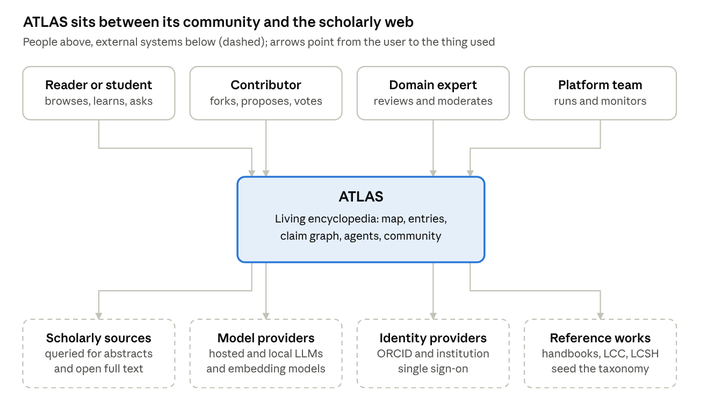
system context · 4 people, 4 external systems
Readers, contributors, experts and the platform team use ATLAS; ATLAS in turn depends on scholarly sources, model providers, identity providers and reference works.

16. C4 Level 2 — Containers
Scope: the deployable units inside ATLAS (web app, services, agent platform, stores) and how they talk.
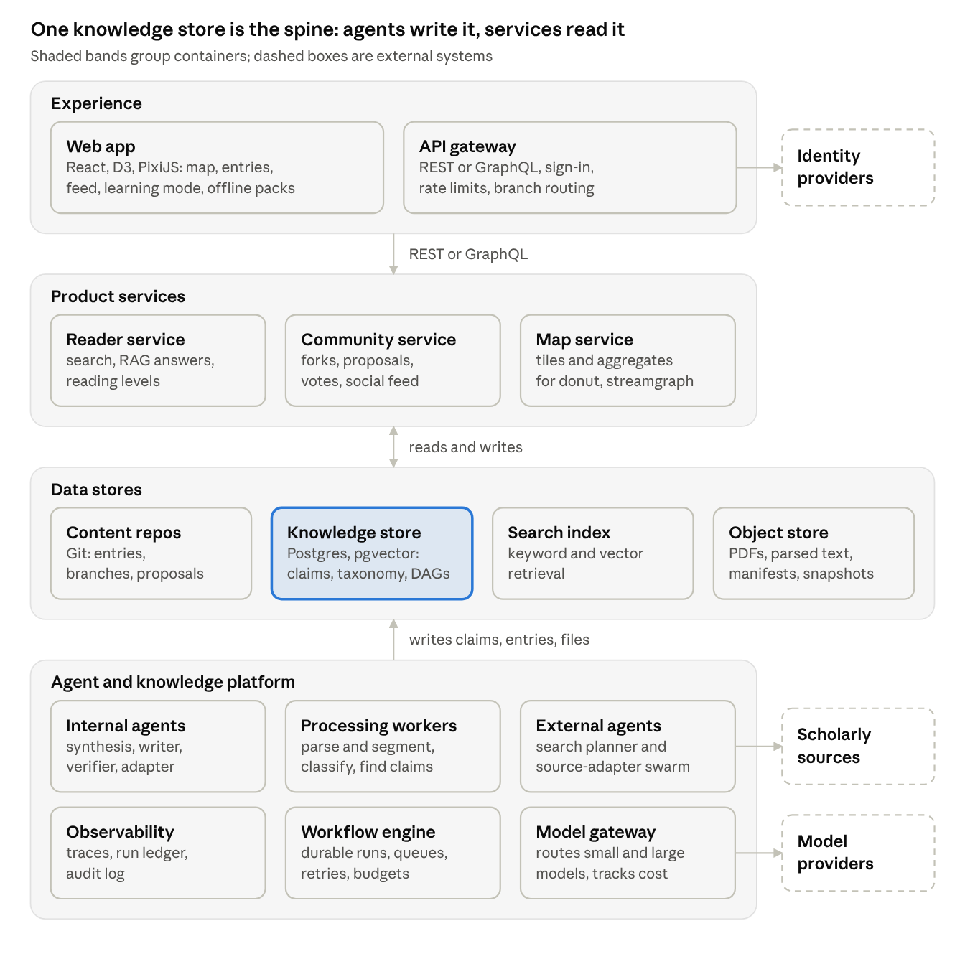
containers · 4 bands, 3 external systems
Product services read the knowledge store, agents write it, and every model call goes through one gateway. Reference works enter through the external agents like any other source.

17. C4 Level 3 — Components of the Agent and Knowledge Platform
Scope: the components inside the container that does the heavy lifting (acquisition, classification, synthesis, writing, RAG).
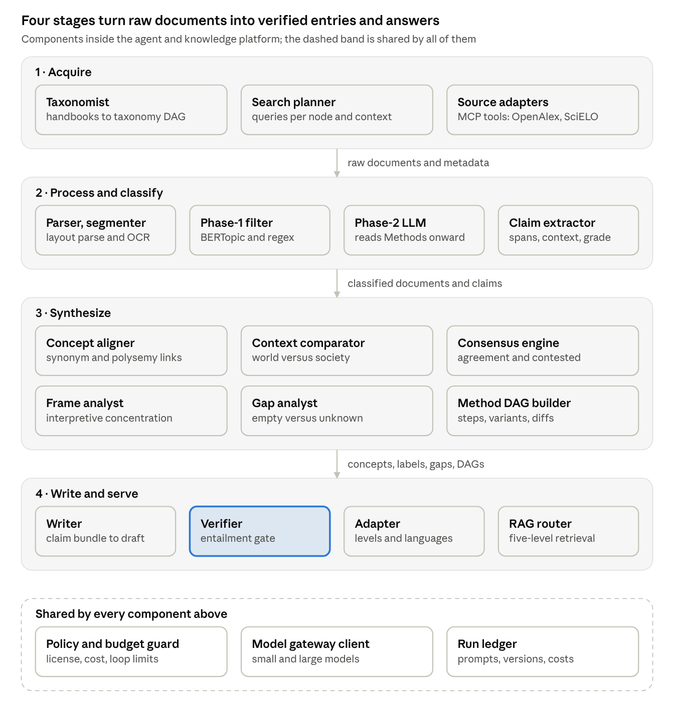
components · 20 components in 4 stages + shared services
The flow is linear until synthesis, where six specialists read the same claim graph; nothing leaves the Verifier gate without passing it. Reviewer assistance for voters is part of the Community service and is not drawn here.

18. Class diagram — core domain model
Scope: the entities of section 4 with their relationships and key attributes.
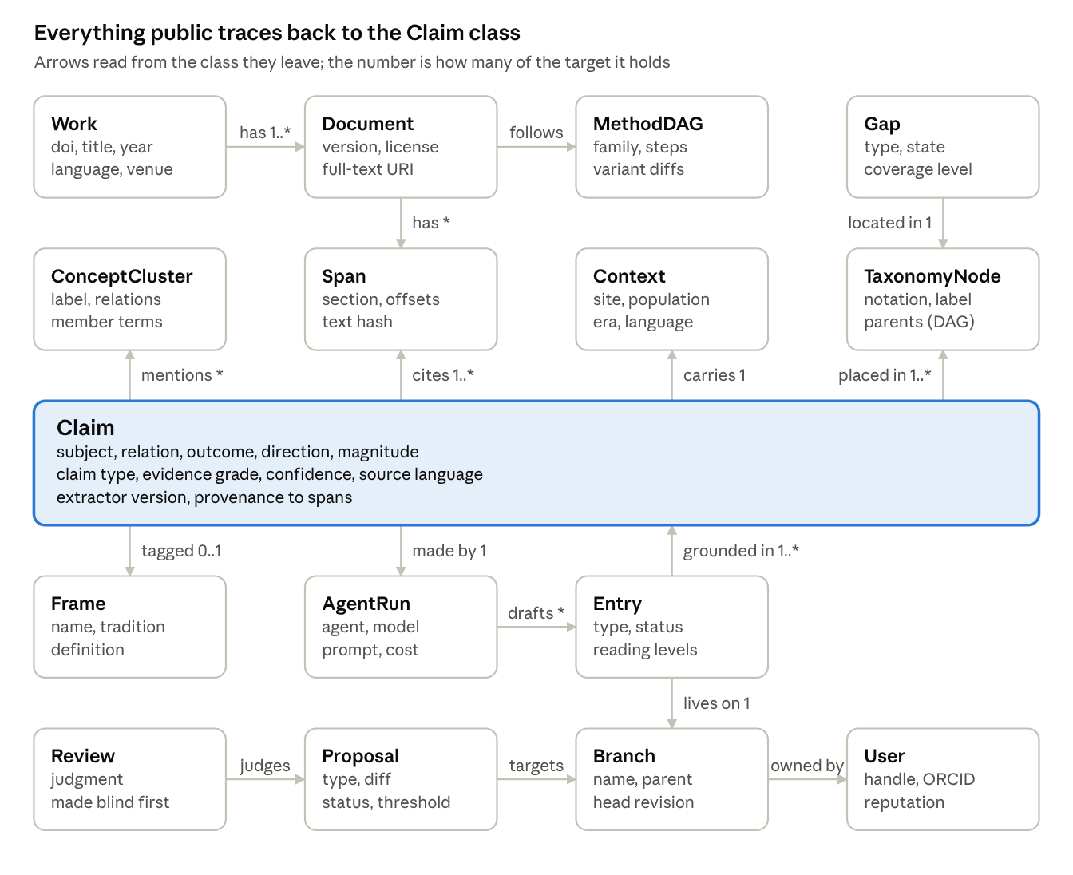
class diagram · 16 classes around Claim
Entries are grounded in claims, claims cite spans of documents, and every claim records the agent run that produced it. Author profiles are Entry records of a dedicated type, so they inherit the same branch, proposal and review mechanics.

19. Activity diagram 1 — From search plan to classified corpus
Scope: stages 0–4 of the pipeline, including the abstain-and-escalate path.
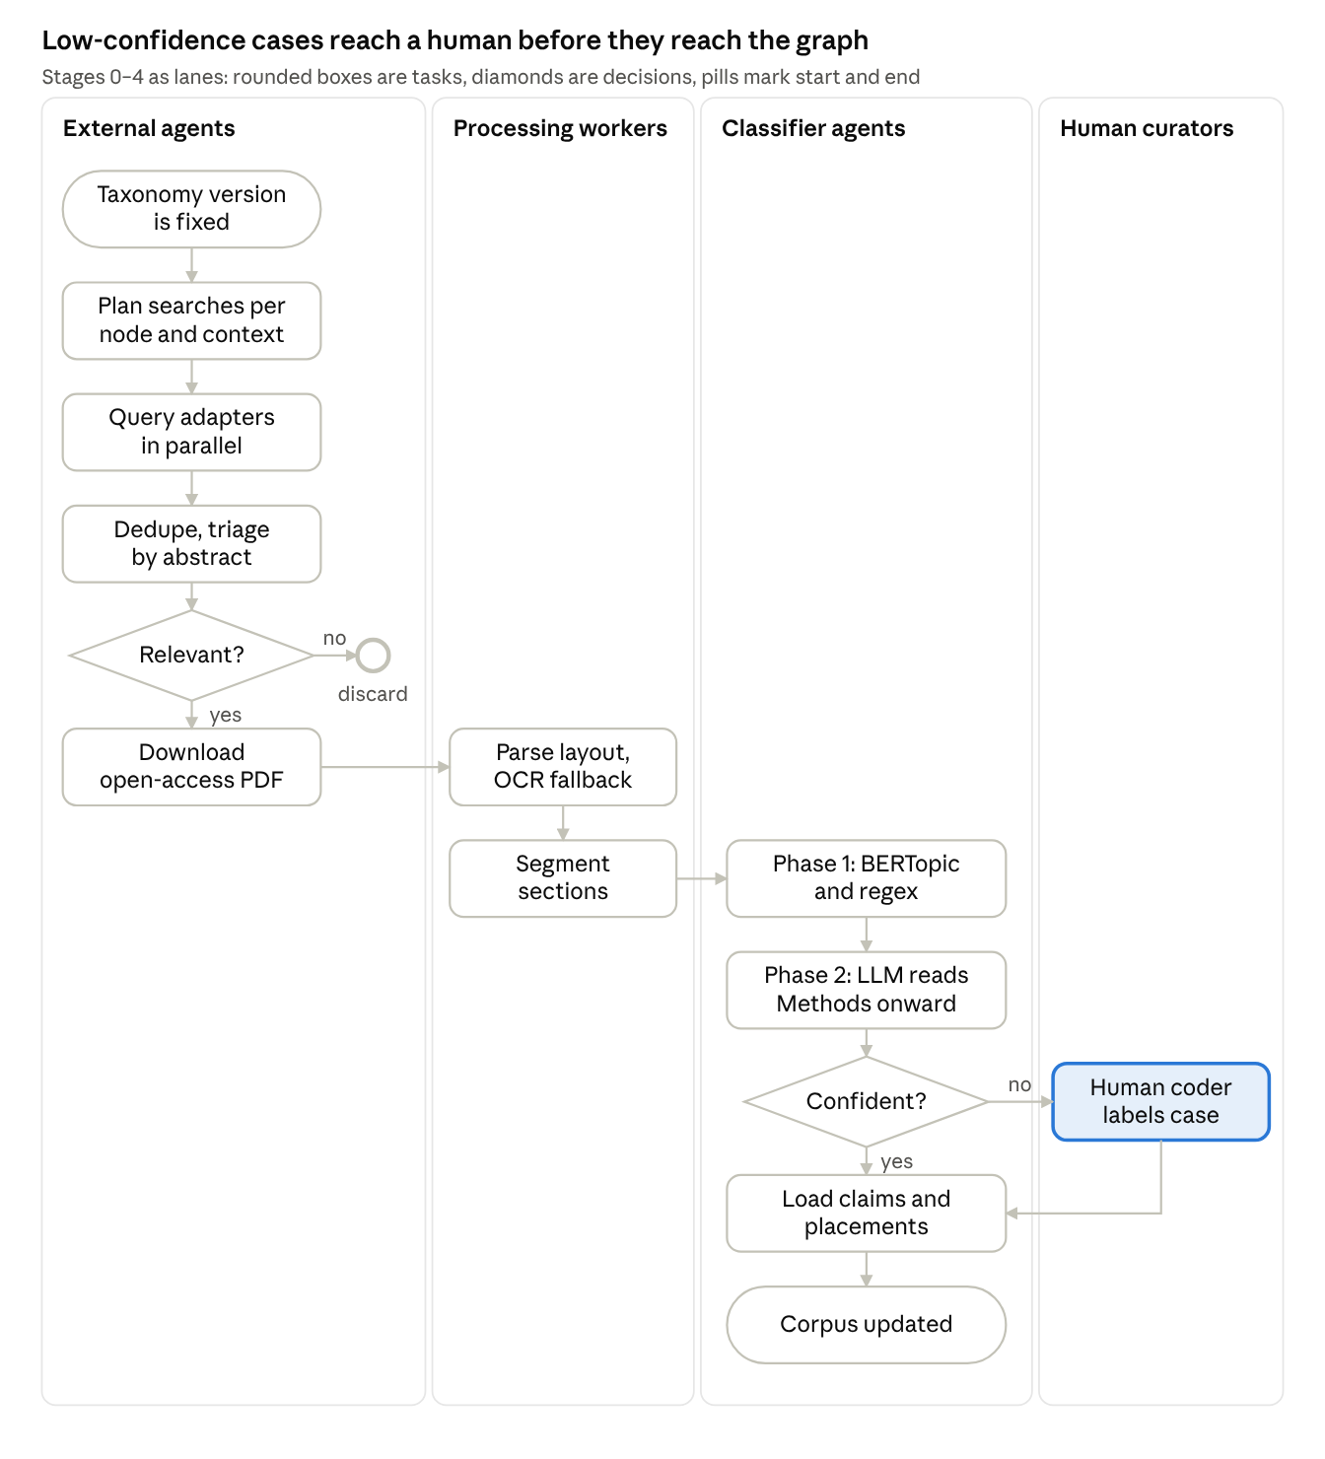
activity diagram · 4 lanes, 2 decisions
A document that fails the relevance check is logged and dropped. A classification the model is not confident about goes to a human coder, and the result rejoins the flow at the step that loads claims into the graph.

20. Activity diagram 2 — Entry generation with verification
Scope: the internal orchestrator, the writer–verifier loop and the publication tiers.
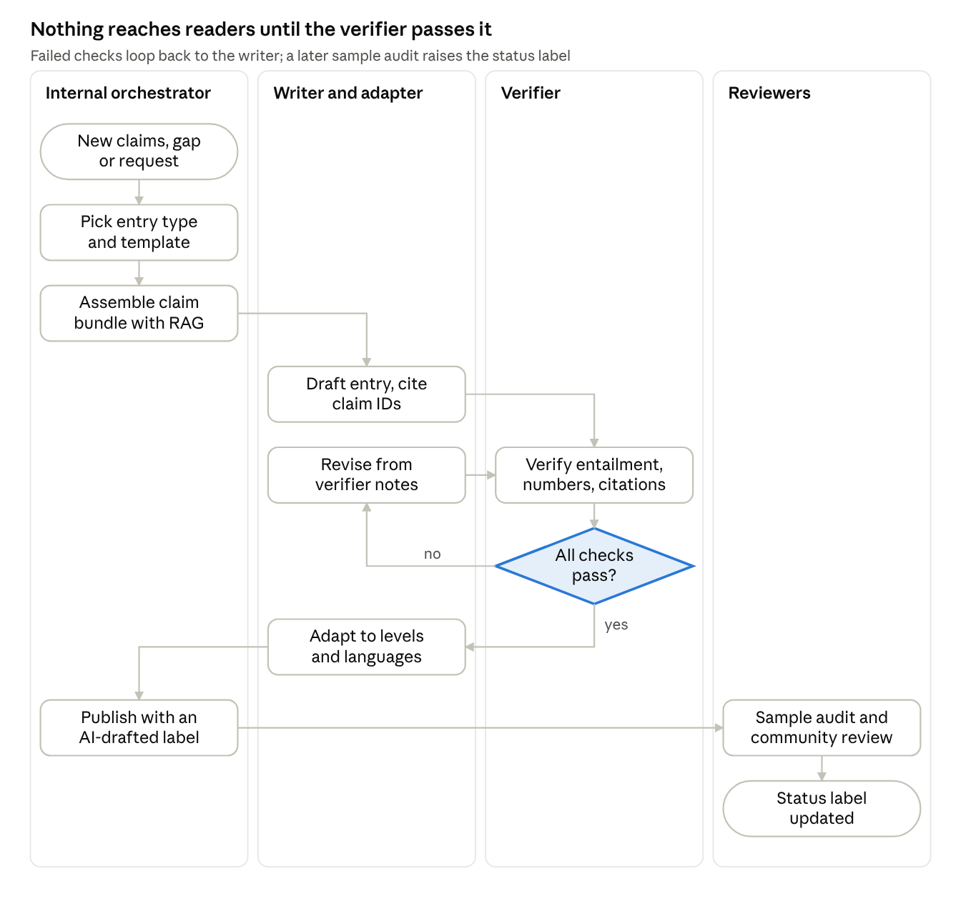
activity diagram · 4 lanes, 1 decision, 1 loop
On a failed check the writer revises from the verifier’s notes and the draft is checked again. After publication, a sample audit by reviewers can raise the entry’s status label.

21. Activity diagram 3 — Fork, propose, vote, merge
Scope: the community workflow with blind-first review and the AI recommendation.
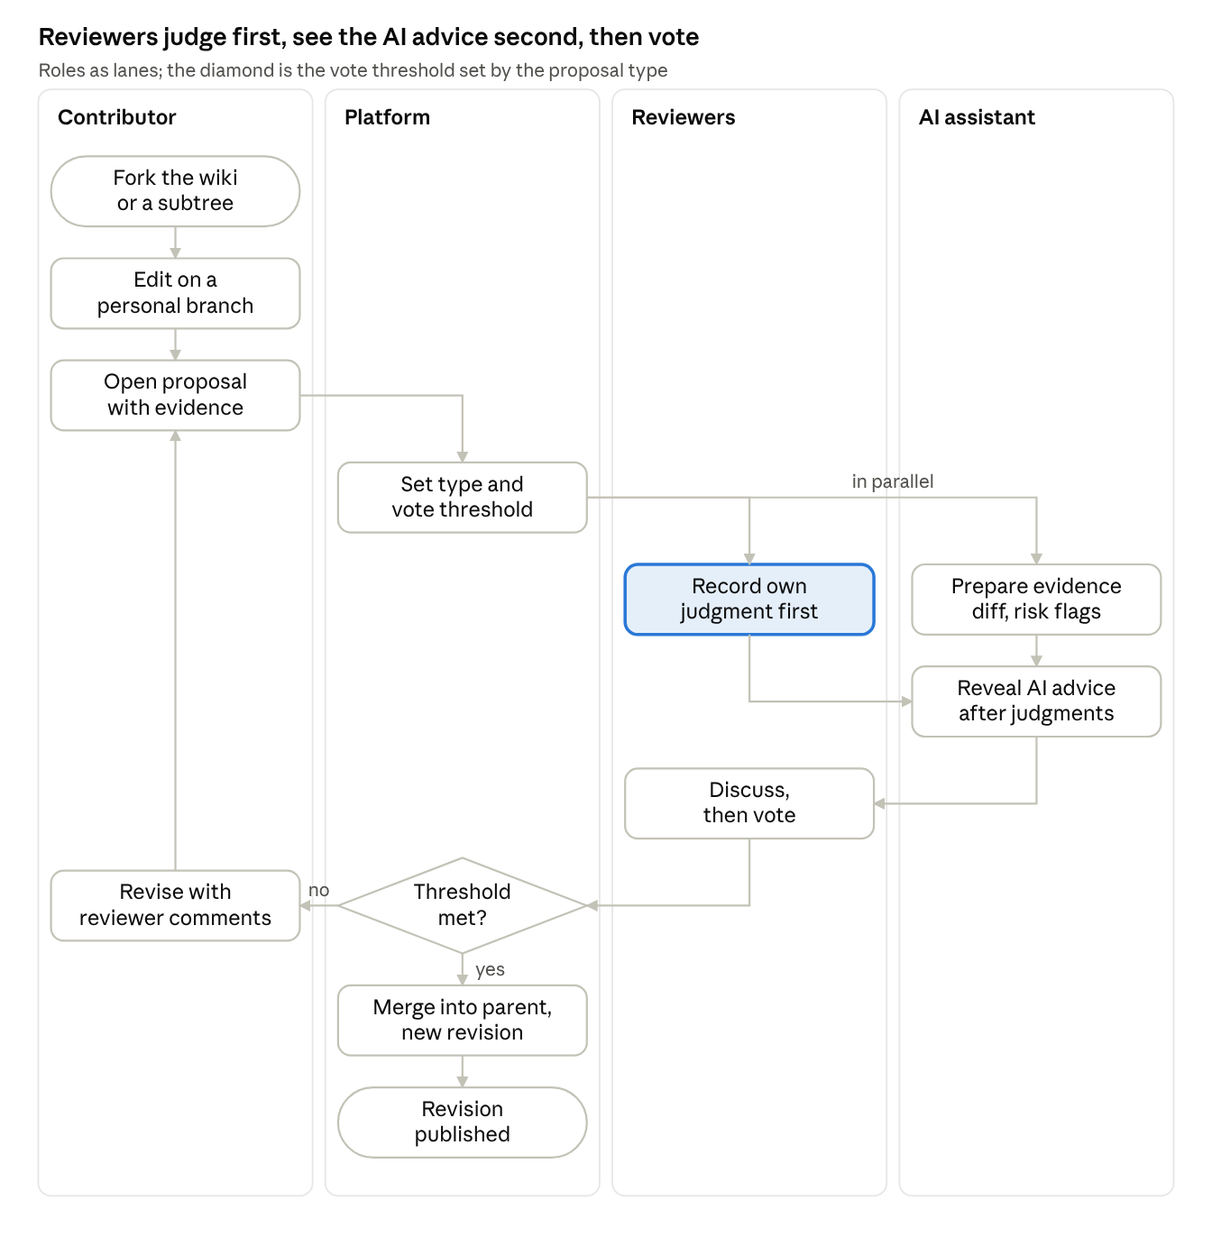
activity diagram · 4 lanes, 1 decision, 1 parallel split
The AI recommendation is shown only after each reviewer has recorded a judgment, which limits anchoring. A proposal that misses its threshold returns to the contributor for revision.

22. Missing pieces
Three additions: evidence upload (22a), theme and palette (22b), and a way to tell theory, empirics and method apart (22c). Section 22d lists what each one changes elsewhere in this guide. Diagrams 15–21 have not been redrawn for them yet.

22a. Multimedia evidence upload
Principle. Uploaded media is contributed evidence, a separate tier from published scholarly sources. It is private on upload, visible to reviewers next, public only after review, and it never raises a claim’s evidence grade on its own.
What can be uploaded, and how it is cited
Kind | Examples | Anchor used in citations | Derived automatically
Image | field photos, archive pages, scanned charts | region of the image | thumbnail, OCR text, caption draft, perceptual hash
Audio | interviews, community radio, field recordings | time range | timestamped transcript, language ID, speaker turns
Video | recorded sessions, demonstrations | time range and frame | keyframes, transcript, captions
Document | scanned letters, forms, reports | page and region | OCR text layer
Dataset | CSV, JSON, GeoJSON | rows, columns or feature | schema profile, preview, checksum
Ingestion flow
- Declare. The contributor says what the file shows, which claim it supports, when and where it was captured, its license and its consent status.
- Scan. Malware scan, file-type check on the real bytes, and caps on size and duration per kind (set from the hosting budget).
- Privacy pass. Location and device metadata are stripped by default. Faces, voices and ID documents are detected; the contributor can blur or distort them, and files with identifiable people are held for review.
- Derive. Transcripts, OCR, keyframes and captions are generated and labelled as machine-derived, with the model version recorded.
- Link. The asset is anchored to a claim through an evidence link (time range, region or page).
- Review. A proposal of type evidence addition goes to reviewers, who check relevance, consent and license.
- Release. Private, then shared with reviewers, then public, or restricted-access if the contributor or a community asks for it.
Rules that matter
- Untrusted input. OCR text and transcripts are data, never instructions, exactly like text from PDFs (principle 6).
- Consent and community ownership. Interviews carry recorded consent. Material held by a community can be marked restricted and handled in the spirit of the CARE principles for Indigenous data governance; takedown is always available.
- Authenticity. Keep the original file hash, read content credentials (C2PA) when present, and flag edited or AI-generated media. AI-generated media never counts as evidence.
- Grading. Contributed evidence has its own grade. It enters consensus only after a reviewer ties it to a checkable observation.
- Accessibility and bandwidth. Alt text or a transcript is required; video has an audio-only fallback; thumbnails load first.
- Copyright. Contributors upload only what they can license, choosing from a short list of licenses.
- Storage. Content-addressed object store; derived files are versioned with the model that made them.
Where readers see it. An evidence badge on the claim, and an Evidence view with synchronized transcript and media. The map itself is unchanged.

22b. Theme, sunburst palette and date transparency
Principles. The interface is neutral grey with a faint cool cast (OKLCH hue 262, chroma 0.005); all colour lives in the data. Each top-level branch gets one hue, assigned in seriation order so neighbouring, related fields have neighbouring hues. Ring depth changes lightness, not hue. Selection uses the ink colour, so no accent colour competes with the data.
Interface neutrals
Token | Light | Dark | Use
bg | #F8FAFE | #0D0E11 | page
surface | #F2F3F7 | #151618 | panels
raised | #E9EBEF | #1D1E20 | hover, cards
hairline | #DCDEE1 | #27292B | dividers
border | #C9CACE | #36383B | controls, hatch lines
muted-fill | #A9ABAE | #56585B | dashed gap outlines
muted-text | #707274 | #848689 | hints (4.6:1 light, 5.3:1 dark)
secondary-text | #4C4D50 | #A9ABAE | secondary text
text | #252629 | #DCDEE1 | body text
ink | #0E0F12 | #F3F5F9 | headings, selection ring
Sunburst palette, light theme (rings 1 to 4 from the centre outwards; Dot is the colour of the study circles)
Branch | Hue | Ring 1 | Ring 2 | Ring 3 | Ring 4 | Dot
1 | 30 | #C17E73 | #D19C93 | #E0BAB3 | #EDD4D0 | #953E32
2 | 66 | #B68858 | #C8A37F | #D9BFA6 | #E8D8C8 | #854F02
3 | 102 | #9C9455 | #B3AD7D | #C9C6A5 | #DEDCC7 | #695F01
4 | 138 | #789F6B | #97B58D | #B6CCAF | #D2DFCE | #386D23
5 | 174 | #54A38E | #7FB9A8 | #A7CEC2 | #C9E1D9 | #056E5A
6 | 210 | #4AA0AF | #79B6C2 | #A3CDD4 | #C7E0E5 | #046A77
7 | 246 | #6597C3 | #89B0D2 | #ADC8E0 | #CCDDED | #08629C
8 | 282 | #8A8CC5 | #A4A6D4 | #BFC1E1 | #D7D9ED | #54529F
9 | 318 | #A882B4 | #BC9EC6 | #D1BBD7 | #E3D5E7 | #794589
10 | 354 | #BC7C96 | #CD9AAE | #DDB9C6 | #EBD4DC | #8F3C62
Sunburst palette, dark theme (outer rings get darker so they recede)
Branch | Hue | Ring 1 | Ring 2 | Ring 3 | Ring 4 | Dot
1 | 30 | #D59185 | #AF756B | #885C54 | #63443E | #FDA293
2 | 66 | #C99A6A | #A57D55 | #816243 | #5E4832 | #EEAF6E
3 | 102 | #AFA767 | #8F8851 | #706A41 | #524E31 | #CCC069
4 | 138 | #8AB27D | #709165 | #58714F | #41533B | #9BCF89
5 | 174 | #67B6A0 | #529583 | #417466 | #32554B | #67D5B8
6 | 210 | #5EB3C2 | #4A939F | #3B737C | #2E545B | #58D1E5
7 | 246 | #77AAD7 | #608BB1 | #4C6D8A | #385064 | #83C5FE
8 | 282 | #9C9ED9 | #7F81B3 | #63658B | #494A65 | #B3B6FE
9 | 318 | #BB94C7 | #9978A4 | #785E80 | #58455D | #DCA7EC
10 | 354 | #CF8EA8 | #AA7389 | #855B6B | #61434F | #F6A0C3
Labels on arcs. Light theme: ink (#0E0F12) on every ring, lowest contrast 5.9:1. Dark theme: dark text (#0E0F12) on rings 1–2, lowest 5.0:1, and light text (#F3F5F9) on rings 3–4, lowest 4.9:1. Study circles reach at least 5.9:1 (light) and 9.9:1 (dark) against the page background at full opacity.
Gaps, voids and focus. Unknown: diagonal hatch in the border colour. Confirmed empty: dashed outline in muted-fill, no fill. Separators between arcs: 1.5 px in the page colour. Selection and keyboard focus: 2 px ink ring.
Diff mode (world versus local) and the theory-versus-evidence lens. One diverging scale, centred on neutral:
Stop | Light | Dark | Meaning
Strong A | #067F94 | #4DB4CC | world stronger (or more theory)
Light A | #9AC7D2 | #376C79
Neutral | #EDEEF1 | #2D2E30 | no difference
Light B | #E1BBAA | #865E4C
Strong B | #AF6340 | #E89772 | local stronger (or more empirical work)
More than ten branches. Do not add hues: closer than about 36° they stop being distinguishable. Group the smallest branches under Other, or colour the second ring instead.
Date transparency. Two modes:
- Absolute (world view): opacity = 0.22 + 0.78 × e^(−age / 30), where age is the current year minus the publication year.
- Relative (zoomed timeline): opacity = 0.25 + 0.75 × (year − first year in view) / (last year − first year in view), so the gradient stays visible at any zoom.
Age in years | 0 | 5 | 10 | 20 | 30 | 60 | 100 | 200+
Opacity | 1.00 | 0.88 | 0.78 | 0.62 | 0.51 | 0.33 | 0.25 | 0.22
Rules: the 0.22 floor keeps old studies visible. Every circle has a 1 px outline at opacity max(0.5, fill) so overlapping old circles stay countable. Undated studies get the floor opacity and a dotted outline. Opacity encodes date only, never evidence quality. The constant 30 is a starting value; tune it against the real date distribution.
const dotOpacity = (year, now) => 0.22 + 0.78 * Math.exp(-Math.max(0, now - year) / 30);

22c. Telling theory, empirics and method apart
Type | Primary contribution | Feeds in ATLAS
Empirical study | Reports results from data the authors collected or analysed (primary or secondary), with a stated procedure | Claims (findings), consensus, gaps
Theoretical essay | Builds, critiques or connects concepts, models or arguments; formal models and simulations belong here when the model itself is the contribution | Frames, concepts, debates
Methodological research | Contributes a procedure, instrument, measure or algorithm, or tests its validity; data illustrate or test it | Method DAG variants, measures registry
Synthesis or review (suggested fourth type) | Systematically combines earlier studies (systematic review, meta-analysis) | Second-hand claims linked to primary studies
Other | Commentary, editorial, news | Excluded from the map by default
Why a fourth type: without it, reviews are forced into one of your three and distort both the empirical count and the consensus numbers.
Primary type plus secondary roles. Mixed papers are common, so each work has one primary type and a list of secondary roles. A theory-building case study is empirical with a theoretical role; an instrument validation is methodological with an empirical role. The label is computed once and stored in the work’s fixed structured record, so every taxonomy node sees the same label and cannot contradict another.
Decision flow. Four yes-or-no questions assign the primary type.
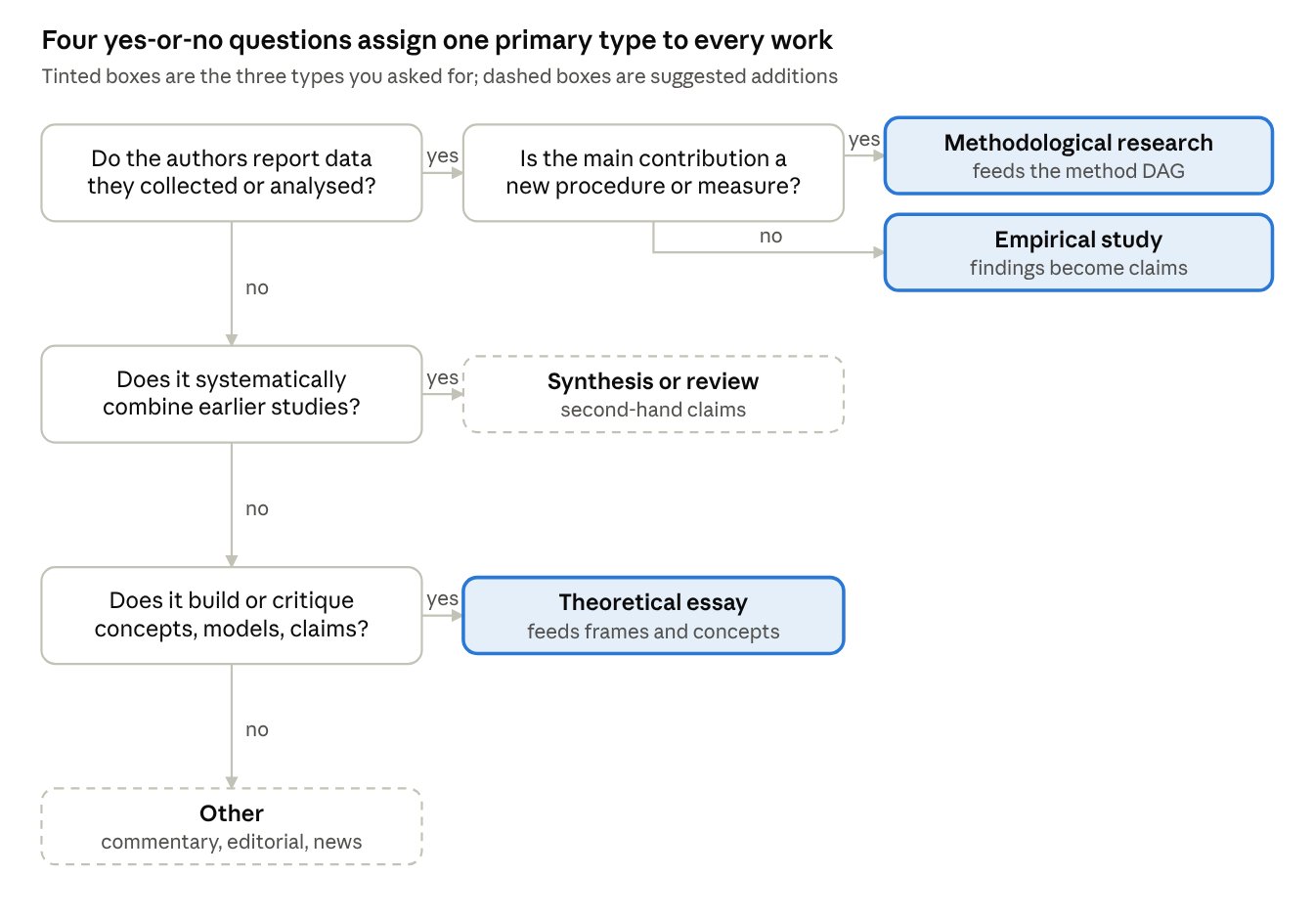
decision flow · 4 questions, 5 outcomes
A mixed paper keeps a single primary type; its other contributions are recorded as secondary roles rather than forcing a fifth category.
How it is detected. A new step, the work-type router, runs before Phase 2 of stage 3, because the reading strategy depends on the type. Empirical works are read from Methods onward. Theoretical essays have no Methods section, so the model reads headings, definitions, propositions and conclusions. Methodological works are read at the procedure and validation sections. Signals: sample and data description, instruments, statistics or quotations (empirical); definitions, propositions and argument structure with no data section (theoretical); step-by-step procedures, validity or reliability evidence, baselines and software releases (methodological). Output fields: primary type, secondary roles, evidence basis (primary data, secondary data, prior studies, none), confidence and supporting spans. Low confidence goes to the human queue. Evaluate on a double-coded gold set, with kappa per type and special attention to two confusions: case studies versus theory, and instrument validation versus empirical work.
What changes downstream
Component | Change
Claim extraction | Empirical works yield findings; theoretical works yield theory statements without effect sizes; methodological works yield procedure claims
Consensus engine | Counts empirical findings only; synthesis claims are flagged second-hand
Frame analyst | Reads theoretical works and interpretive claims
Gap analyst | Adds three gap types: theory-rich but data-poor, data-rich but theory-poor, and method-poor
Method DAG | Methodological works create or change canonical steps; empirical works are instances
Writer and verifier | New verifier check: the type of the cited source must fit the statement, so an essay is never cited for an empirical statement
What readers see. Dot shape marks the type, opacity marks the date and colour marks the subfield, so the three channels never compete. Type chips filter the map, and a theory versus evidence lens colours each arc on the diverging scale above by the ratio of theoretical to empirical studies, which makes theory–evidence gaps visible at a glance.
↗ visual encoding key · shape, opacity, undated
The key shows the shape and opacity channels in a stand-in colour; the real subfield colours are the palette tables in section 22b.

22d. What these additions change
Area | Change
Data model | New classes Asset and AssetDerivative; the evidence link gains a time-range, region or page anchor; Work gains primary type, secondary roles and evidence basis; Claim records the type of its source; proposal types gain evidence addition
Pipeline | Work-type router added before Phase 2 of stage 3; media derivation (OCR, transcription, keyframes) added beside stage 2
Visualization | Shape, opacity and palette as defined in 22b and 22c; type filter chips; theory-versus-evidence lens
Roadmap | 22b and 22c in Phase 1, because they shape classification and the first static map; 22a in Phase 3, when review and moderation exist
Diagrams | Sections 15–21 are not yet redrawn: the class diagram lacks the new classes, and the container and component diagrams lack the media store and the router

